**Tutorial**

**Benthic Terrain Modeler for ArcGIS 10.1 & 10.2**

September 2013

# Introduction

This tutorial will introduce you to the **Benthic Terrain Modeler (BTM)** toolbox for ArcGIS v10.1 & 10.2, a collection of Esri® ArcGIS®-based tools that coastal and marine resource managers can use in concert with bathymetric data sets, in order to examine and classify the benthic environment. The BTM toolbox contains a set of customized scripts that allow users to create grids of bathymetric position index (BPI), standardized BPI’s, slope, rugosity, and other geomorphometric measurements from an input bathymetric data set. Additionally, a terrain classification script gives users the freedom to create their own zone and structure classifications and define the relationships that characterize them.

The BTM toolbox for ArcGIS creates a user-defined classification system of benthic terrain. The BTM scripts transform digital elevation data into a classified product for use in research or natural resource management. However the principles behind the tool are general enough to be used on any digital elevation data. The inclusion of flexible and customizable terrain classifications allows investigators and managers to create terrain maps in a variety of environments. To learn more about the original tool development and its applications in natural resource mapping and coastal management please refer to the BTM document located at the link below. More resources including information on BTM product development and community support can be found in the appendix. <http://proceedings.esri.com/library/userconf/proc04/docs/pap1433.pdf>

The BTM was initially developed as a desktop extension for ArcGIS versions 8.x through 9.2 Service Pack 3. The version for ArcGIS 10.1 & 10.2 is comprised of a series of ArcPy scripts combined in a custom Toolbox that allows the user to run the individual processes as separate functions, or in a graphical environment from a Python Add-in. The updated version also allows the tools to run on any kind of raster data supported by ArcGIS, including Bathymetric Attributed Grids (BAGs), GeoTIFFs, and raster GRIDS. The initial project was a partnership between the NOAA Coastal Services Center and Oregon State University. The current version of the Benthic Terrain Modeler is also a joint collaboration between NOAA CSC, [the Massachusetts Office of Coastal Zone Management](http://www.mass.gov/czm), and [Esri](http://www.esri.com/industries/natural-resources/oceans/index.html). Contact information regarding technical support and product development is located in the appendix.

**Benthic Terrain Modeler for ArcGIS Functions:**

* **Build Bathymetric Position Index (BPI) Grids** The creation of Bathymetric Position Index (BPI) data sets at two different scales is central to the methods behind the benthic terrain classification process. BPI is a derivative of the input bathymetric data set, and is used to define the location of specific features and regions relative to other features and regions within the same data set.
  + **Build Broad-Scale BPI** creates a broad-scale BPI data set that allows you to identify larger regions within the benthic landscape.
  + **Build Fine-Scale BPI** creates a fine-scale BPI data set that allows you to identify smaller features within the benthic landscape.
* **Standardize BPI’s** creates standardized BPI data sets that may be classified to identify various benthic zones and/or structures.
* **Calculate Aspect** creates an aspect raster to be used in the classification tools.
* **Calculate Curvature** creates a ‘slope of slope’ raster, and can optionally calculate plan and profile curvature.
* **Calculate Slope** creates a slope raster to be used in the classification tools.
* **Calculate Depth Statistics** calculates depth summary statistics, such as mean, variance and standard deviation, over a set neighborhood size. These statistics can be useful predictors in understanding the benthic zones in analyses tasks like habitat classification.
* **Classify Benthic Terrain:** creates a user-defined structures layer based on BPI’s, slope, standard deviation breaks, and depth. The benthic zones in the output layer include crests, depressions, flats, and slopes. The benthic structures in the output layer will consist of narrow depression, local depression on flat, lateral midslope depression, depression on crest, broad depression, broad flat, shelf, open slopes, local crest in depression, local crest on flat, lateral midslope crest, narrow crest, and steep slope. *Note: this tool combines the* ***Zone Classification Builder*** *and* ***Structure Classification Builder*** *steps of the toolbox provided at ArcGIS 10.0*.
* **Terrain Ruggedness (VRM)** measures terrain ruggedness, or rugosity, as the variation in three-dimensional orientation of grid cells within a neighborhood. Vector analysis is used to calculate the dispersion of vectors normal (orthogonal) to grid cells within the specified neighborhood. This method effectively captures variability in slope and aspect into a single measure. Ruggedness values in the output raster can range from 0 (no terrain variation) to 1 (complete terrain variation). Typical values for natural terrains range between 0 and about 0.4.

# *Note: The BPI, Slope, and Classification Builder scripts are all part of a single benthic terrain modeling process. The Terrain Ruggedness (VRM) script is an add-on for identifying rugosity in the benthic terrain environment that yields results unrelated to BPI.*

# Setup Instructions for Benthic Terrain Modeler for ArcGIS

BTM for ArcGIS 10.1 & 10.2 is packaged as a .zip file. Unzip the contents to your computers root **C:** drive in order to follow the tutorial steps below. The file location should read: ***C:\BTM_Tutorial***. Within the **BTM_Tutorial** folder are two folders, one containing the BTM Toolbox with scripts, and another containing sample data that will be used throughout the tutorial.

*Note: The program files may be saved anywhere but in doing so the paths will differ for the following instructions.*

1. To add the Benthic Terrain Modeler toolbox into ArcMap, first open a new map project.
2. Open the ArcToolbox window by clicking **Geoprocessing > ArcToolbox** and pin it to the display if it is not already. Right-click on the ArcToolbox top folder in the window and select **Add Toolbox**. Navigate to the **C:\BTM_Tutorial\toolbox** folder and add **BTM.pyt**.
3. Expand the BTM toolbox in ArcToolbox to see it consists of 7 Python scripts. Note that the Spatial Analyst extension is required to run the BTM tools.

*Note: This tutorial only guides the user on how to perform the BTM functions using the provided sample data and estimated input values. Bathymetric values and data ranges vary greatly from one area to another and this should be noted when using the BTM with your own data sets.*

*Also, this tutorial also does not fully explain the processes that run the scripts in ArcMap. This tutorial is intended to guide the user on the script-based version of the BTM for ArcGIS 10.x. If interested in the information regarding the initial product development and the processes that BTM utilizes, please refer to the original BTM for ArcGIS 8.x user documentation found at* [*http://www.csc.noaa.gov/digitalcoast/tools/btm/index.html*](http://www.csc.noaa.gov/digitalcoast/tools/btm/index.html) *and click on the BTM Tutorial for ArcGIS 9.2 link.*

## BTM Tutorial

### Add the sample map.

### Click on **Open** and navigate to the **C:\BTM_Tutorial\sample_data** folder and open **btm.mxd**. Bathymetric data are the only data required for the BTM tools. The included hillshade layer can be used to enhance the visualization of the results, but does not affect the mechanics of the actual tools.

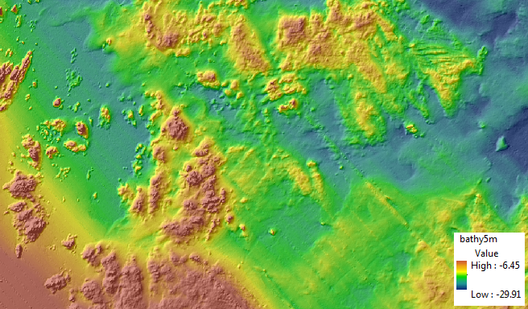

The bathymetric data used in this tutorial was collected by the U.S. Geological Survey and the National Oceanic and Atmospheric Administration offshore of Massachusetts between Duxbury and Hull. These data are available as an ArcInfo 32-bit floating point binary grid in Environmental Systems Research Institute (ESRI) format. The GRID has a 5-meter horizontal resolution and the spatial reference is WGS_1984_UTM_Zone_19N. For more information on acquiring bathymetric data for use with the BTM please visit: <http://pubs.usgs.gov/of/2009/1072/html/appendix1.html>.

For each of the following steps, the tools can be accessed one of two ways: either by using the BTM menu in ArcMap, or using the toolbox directly. Below, the geoprocessing tool dialogs are shown. To access the BPI tools, use the Bathymetric Position Index menu of the Add-in:

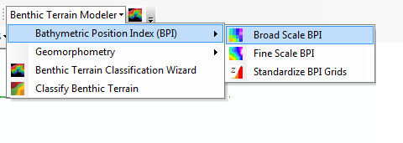

### Build Broad Scale BPI

1. Double-click the first script, **Broad Scale BPI**, in the BTM toolbox to open it. Populate the script with the following parameters :

***Input bathymetric raster*:** C:\BTM_Tutorial\sample_data\bathy5m.tif

***Inner radius*:** 25

***Outer radius:*** 250

***Output raster:*** C:\BTM_Tutorial\sample_data\broad_bpi

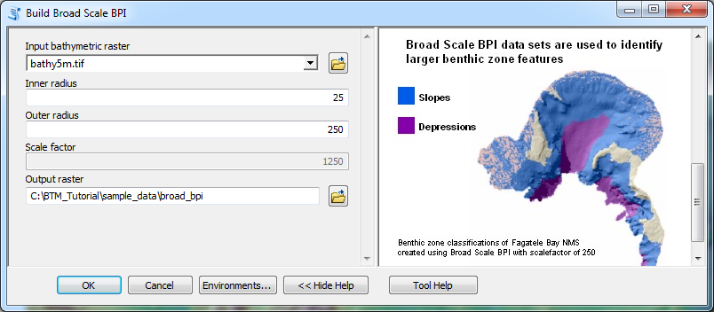

1. Note that a **scale factor** is automatically computed based on the input radii. Click **OK** to run the script. Once the script runs the symbology will need to be changed. Double-click the **broad_bpi** layer in the table of contents, select the **Symbology** tab, and then select the **Stretched** display option. Change the color ramp if necessary. Click **Apply** and then **OK**. Drag the layer beneath the hillsahde5m layer. Your results should look similar to the graphic below for the Broad Scale BPI.

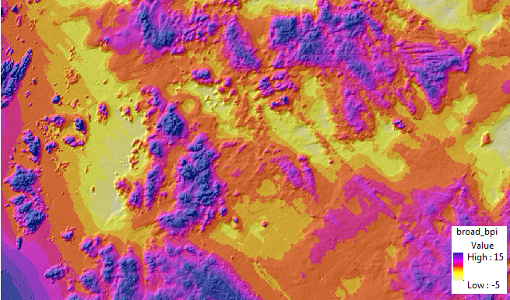

### Build Fine Scale BPI Note: Fine Scale and Broad Scale BPI tools are functionally the same, but for many classification tasks, both are required.

1. Double-click the second script in the BTM toolbox, **Fine Scale BPI**, to open it. Populate the script with the following parameters :

***Input bathymetric raster*:** C:\BTM_Tutorial\sample_data\bathy5m.tif

***Inner radius*:** 3

***Outer radius*:** 25

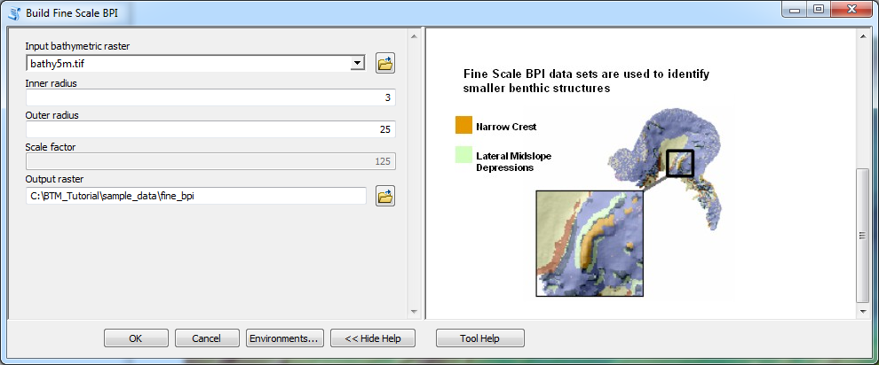***Output raster*:** C:\BTM_Tutorial\sample_data\fine_bpi

1. As with the broad BPI, note that the scale factor is automatically computed. Click **OK** to run the script. Once the script runs the symbology will need to be changed. Double-click the **fine_bpi** layer in the table of contents, select the **Symbology** tab, and then select the **Stretched** display option. Change the color ramp to match the **broad_bpi** color ramp. Click **Apply** and then **OK**. Drag the layer beneath the hillshade5m layer. Your results should look similar to the graphic below for the Fine Scale BPI.

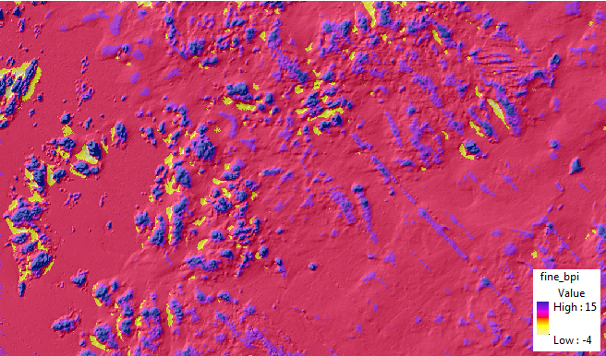

1. Toggle between the **broad_bpi** and **fine_bpi** layers to note the differences between the broad scale and fine scale bathymetric position index grids.

### Standardize BPI Grids

1. 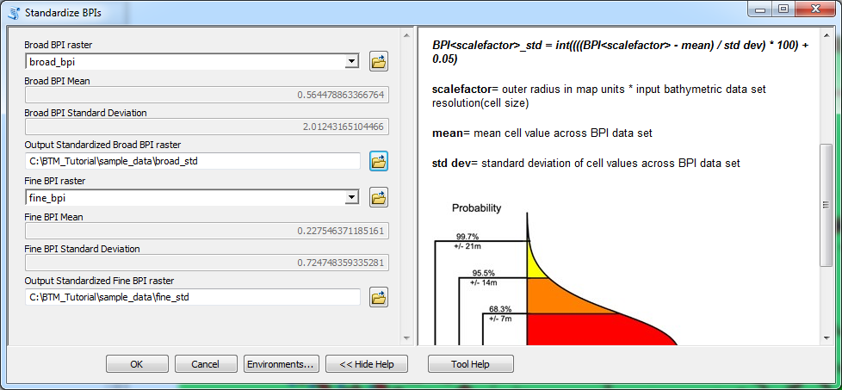Double-click the **Standardize BPIs** script in the BTM toolbox to open it. First standardize the broad scale BPI. Select **broad_bpi** as the input raster, name the output **broad_std**. Note that the mean and standard deviation of the raster are computed automatically, and can be useful guides for interpreting the results. Next, select **fine_bpi** as the second input raster, and name the output **fine_std**.

1. Click **OK** to run the script. Once the script runs the symbology will need to be changed as in the previous steps. Drag the layer beneath the hillshade5m layer. Your results should look similar to the graphic below for the Standardized Broad Scale BPI and Standardized Fine Scale BPI rasters.

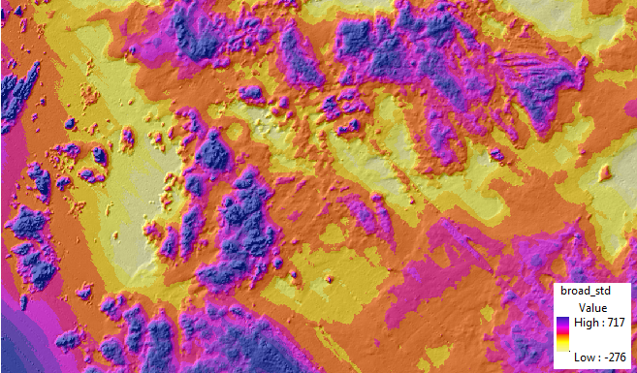

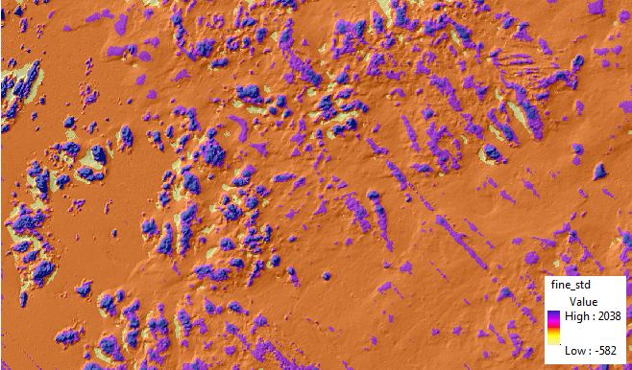

BTM also supports a range of geomorphology operations. Slope is a required input for the BTM classification task, and can be accessed from the Geomorphometry menu of the Add-in:

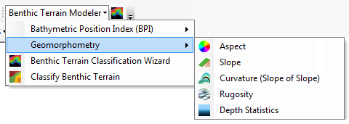

### Calculate Slope

1. Double-click the **Calculate Slope** script in the BTM toolbox to open it. The output slope raster will be used in the following scripts. Select the **bathy5m** raster as the input and name the output file **slope**, saving it to the **sample_data** folder.

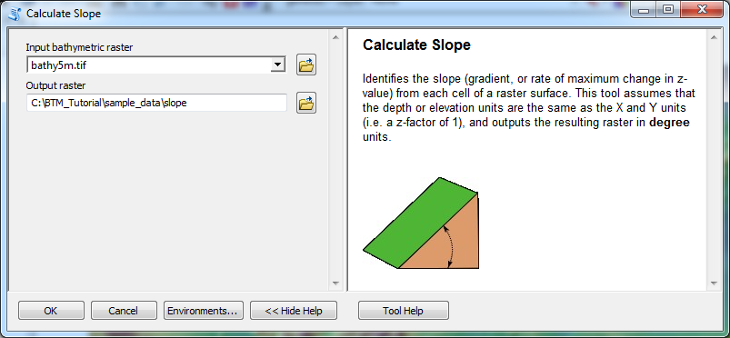

1. Click **OK** to run the Calculate Slope script. Once the **slope** layer is added to the map change the color ramp in the layer properties and then drag it beneath the hillshade5m layer in the table of contents. Your layer should have slope values similar to the graphic below.

*Note: artifacts in the bathymetry data may be magnified by some of the steps as seen below. In this case, small NW to SE changes in bathy are highlighted caused by verging multibeam swathes.*

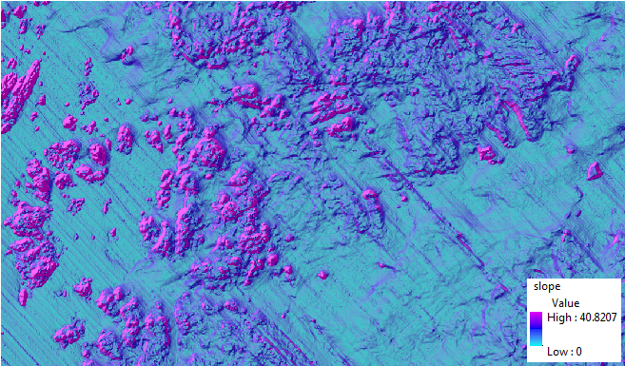

### Classify Benthic Terrain

*Note: the 10.0 version of these tools provided two tools, a “Zone Classification Builder” and a “Structure Classification Builder”. Both of the tools used the same model, but represented the classification problem in different terms. In this version of the tool, we have retained the original BTM method of classifying benthic terrain based on a classification dictionary, which can be used to generate both structures and zones.*

1. Open and inspect the classification dictionary, which maps ranges of input rasters to specific classes. An example dictionary is included as : C:\BTM_Tutorial\sample_data\fagatelebay_classification.csv  
   If you open the file, you should see a spreadsheet that looks like following:  
     
   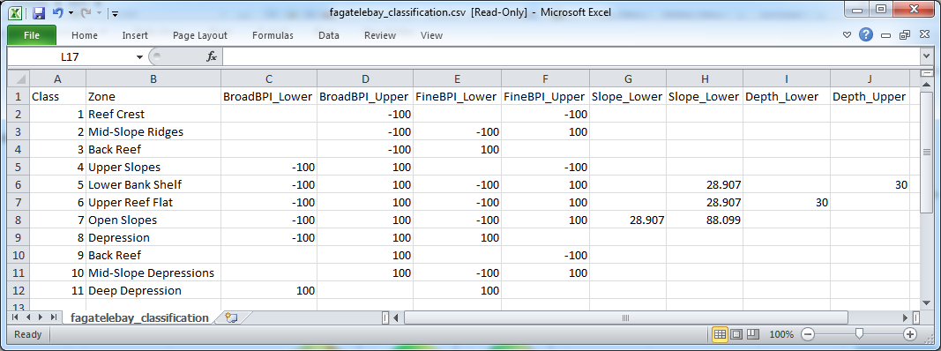  
   The first column in the sheet provides numerical class codes, which will be written to the output raster. The second column provides descriptive names, which could be structures, zones, or other classifications. The other columns in the spreadsheet define the ranges of values which describe specific classes in the output.  
   BTM previously used an XML-based classification dictionary, authored within the classification wizard itself. The current tool can still read and use the older format, but CSVs were preferred for their easy authoring, and direct Excel support is planned for the 10.2 version of the tool.
2. Double-click the **Classify Benthic Terrain** tool in the BTM toolbox to open it. Populate the script with the following input parameters:

***Classification dictionary:*** C:\BTM_Tutorial\sample_data\fagatelebay_classification.csv  
***Standardized broad-scale BPI raster*:** C:\BTM_Tutorial\sample_data\broad_std

***Standardized fine-scale BPI raster:***C:\BTM_Tutorial\sample_data\fine_std

***Slope raster*:** C:\BTM_Tutorial\sample_data\slope

***Bathymetric raster*:** C:\BTM_Tutorial\sample_data\bathy5m

***Output raster:*** C:\BTM_Tutorial\sample_data\structures

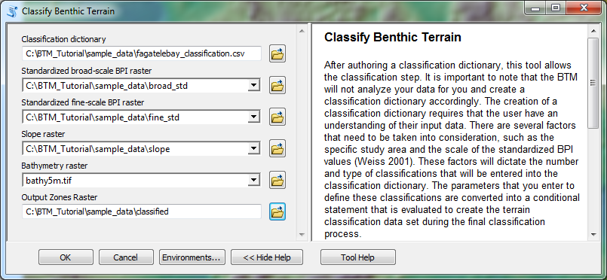

1. Click **OK** to run the script. Drag the **classified** layer beneath the hillshade5m layer in the table of contents and change the ramp color to your preference. Your **classified** layer should look similar to the graphic below.

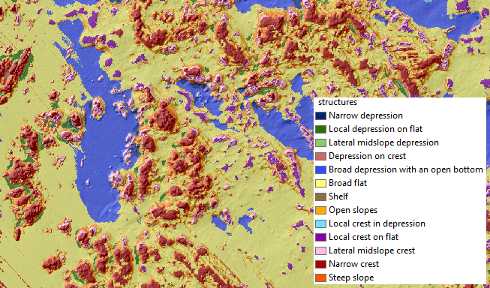

### Terrain Ruggedness (Vector Ruggedness Measure)

1. Double-click the **Terrain Ruggedness (VRM)** script in the BTM toolbox to open it. Populate the script with the following input parameters

***Elevation Raster*:** C:\BTM_Tutorial\sample_data\bathy5m

***Neighborhood Size:*** 3

***Output Workspace:*** C:\BTM_Tutorial\sample_data

***Output raster:*** C:\BTM_Tutorial\sample_data\rug_5m

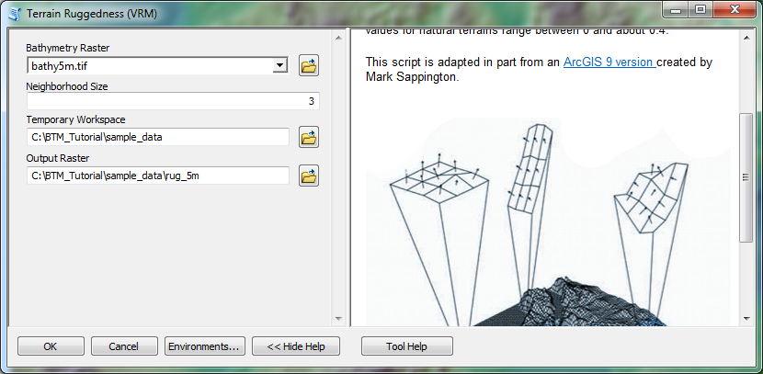

1. Click **OK** to run the script. Drag the **rug_5m** layer beneath the hillshade5m layer in the table of contents and change the ramp color to your preference. Your **rug_5m** layer should look similar to the graphic below.

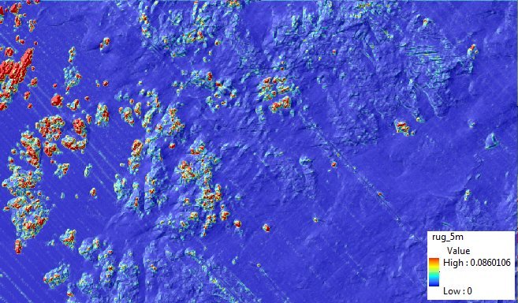

1. Ruggedness values in the output raster can range from 0 (no terrain variation) to 1 (complete terrain variation). Typical values for natural terrains range between 0 and about 0.4, however it is important to understand that the number is unitless and not directly comparable between study sites. This script, originally created by Mark Sappington, was adapted for ArcGIS v10 by the Massachusetts Office of Coastal Zone Management. For more information regarding the script processes please refer to:

Sappington, J.M., K.M. Longshore, and D.B. Thompson. 2007. Quantifying

Landscape Ruggedness for Animal Habitat Analysis: A Case Study Using Bighorn Sheep in the Mojave Desert. Journal of Wildlife Management. 71(5): 1419 -1426.

# **Appendix**

**Contact Information and Technical Assistance:**

**Esri**

**Shaun Walbridge**

[**swalbridge@esri.com**](mailto:swalbridge@esri.com)

**805-722-9025**

Dawn Wright, Ph.D.

dwright@esri.com

909-793-2853, ext. 2182

esri.com/oceans

**NOAA Coastal Services Center**

Matt Pendleton

843-740-1196

[Matt.Pendleton@noaa.gov](mailto:Matt.Pendleton@noaa.gov)

**Massachusetts Office of Coastal Zone Management**

Dan Sampson

[daniel.sampson@state.ma.us](mailto:daniel.sampson@state.ma.us)

Emily Huntley

[emily.huntley@state.ma.us](mailto:emily.huntley@state.ma.us)

617-626-1241

**BTM Development and Support Information:**

Wright, D. J., E. R. Lundblad, E. M. Larkin, R. W. Rinehart, J. Murphy, L. Cary-Kothera, and K. Draganov. 2005. ArcGIS Benthic Terrain Modeler. Corvallis, Oregon, Oregon State University, Davey Jones Locker Seafloor Mapping/Marine GIS Laboratory and NOAA Coastal Services Center. Accessible online at: <http://www.csc.noaa.gov/digitalcoast/tools/btm>.

Alternate BTM Tutorial for ArcGIS 8.x, 9.x

<http://dusk.geo.orst.edu/buffgis/Arc9Labs/lab3_analysis_modelsS09.pdf>

Seafloor Mapping/Marine and Coastal GIS – Oregon State University

<http://marinecoastalgis.net/>